EGM generation in infinite medium
P

The infinite length slap

Figure 1 Situation sketch. Passing wave front under an electrode in infinite space
When we assume an infinite dipole layer within an excitable medium, the strength of the generated signal in point P is defined by the solid angle of the passing wave front. However, in reality the wave front is not infinitesimal thin, but has a certain thickness. Thus the strength of the wave front is determined by the first derivative of the action potential function. In the heart the strength is determined by the trans membrane potential, which has a sharp upstroke of about 2-3 ms and a slow decay back to the resting potential.
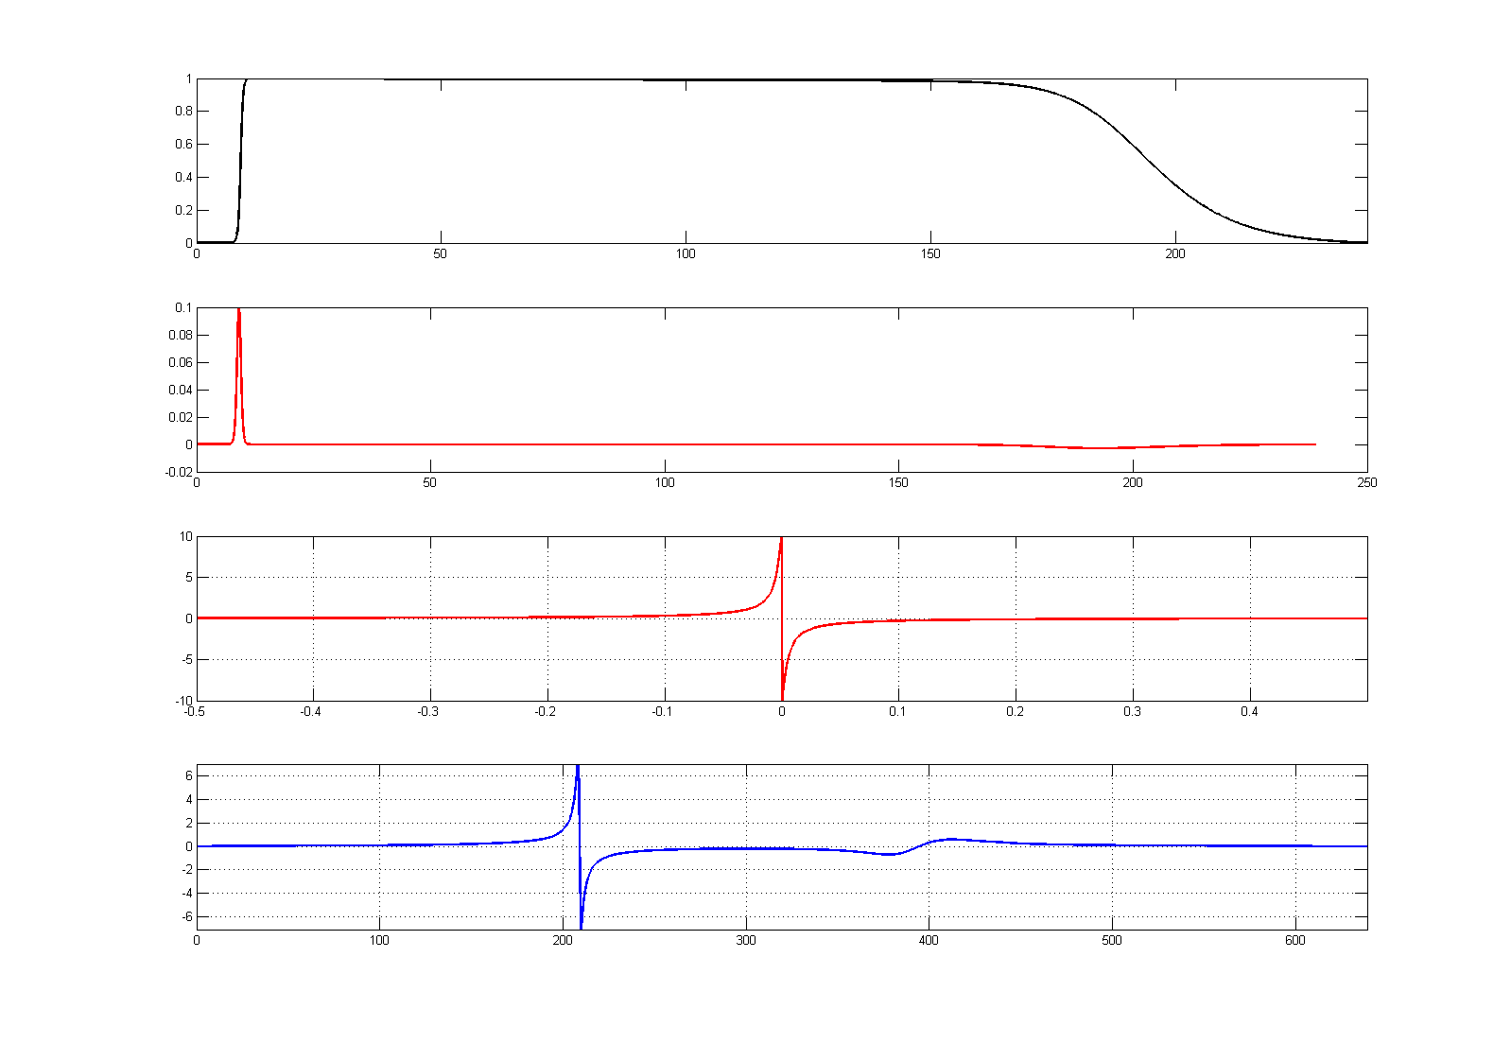
Figure 2 Top panel: Action potential. Second panel: first derivative of the action potential (AP). Third panel the solid angle of a uniform strength dipole layer (SA). Bottom panel: convoluted first derivative of AP and the SA.

